**C-DAC Mumbai Date 25/09/2024**

**Subject: Algorithm and Data Structure**

**Assignment 1**

**Solve the assignment with following thing to be added in each question.**

-Program

-Flow chart

-Explanation

-Output

-Time and Space complexity

1. Armstrong Number

Problem: Write a Java program to check if a given number is an Armstrong number.

Test Cases:

Input: 153

Output: true

Input: 123

Output: false

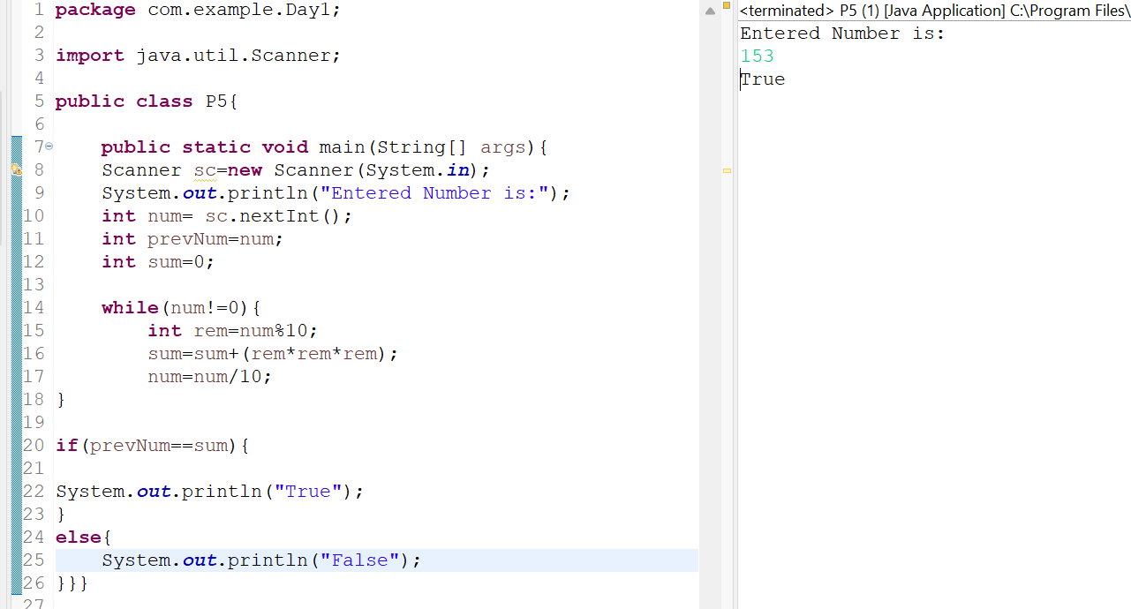

2. Prime Number

Problem: Write a Java program to check if a given number is prime.

Test Cases:

Input: 29

Output: true

Input: 15

Output: false



3. Factorial

Problem: Write a Java program to compute the factorial of a given number.

Test Cases:

Input: 5

Output: 120

Input: 0

Output: 1

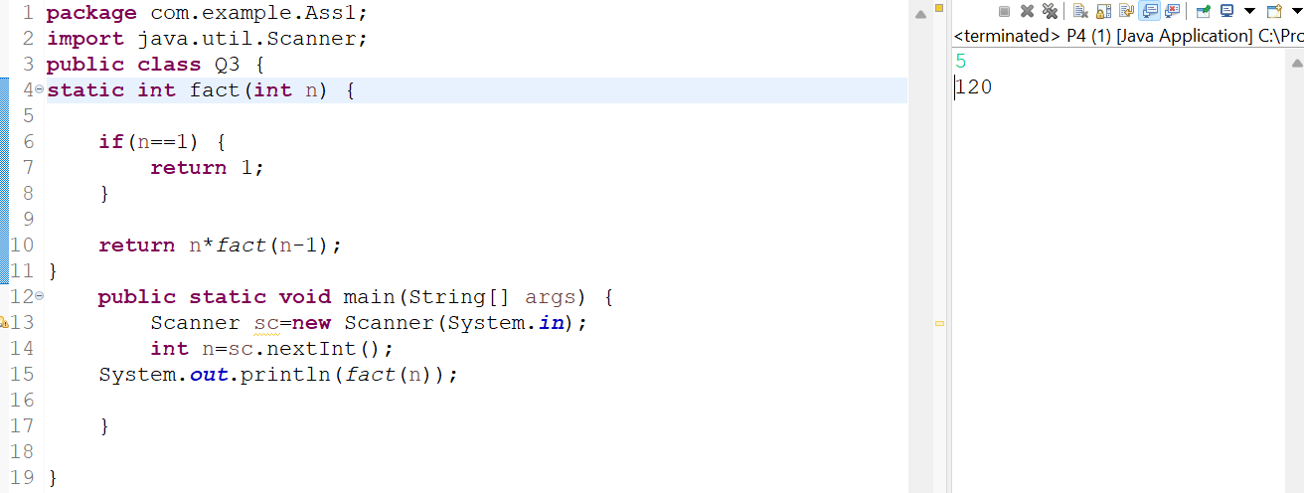

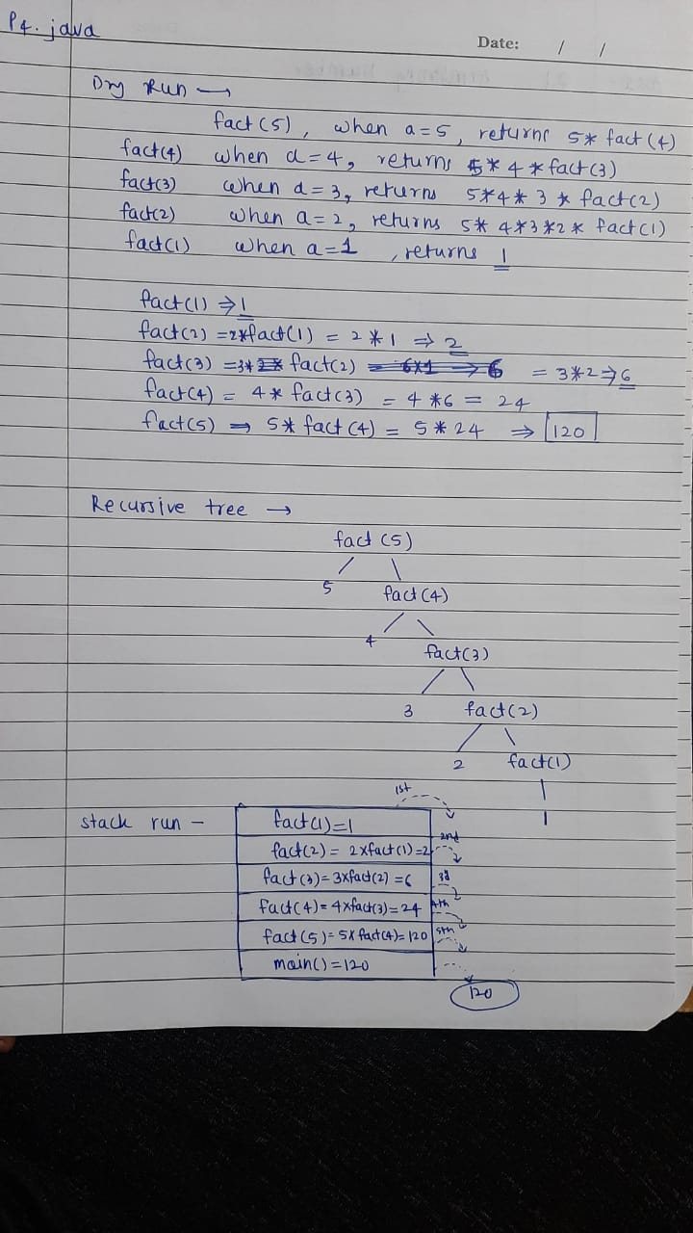

4. Fibonacci Series

Problem: Write a Java program to print the first n numbers in the Fibonacci series.

Test Cases:

Input: n = 5

Output: [0, 1, 1, 2, 3]

Input: n = 8

Output: [0, 1, 1, 2, 3, 5, 8, 13]

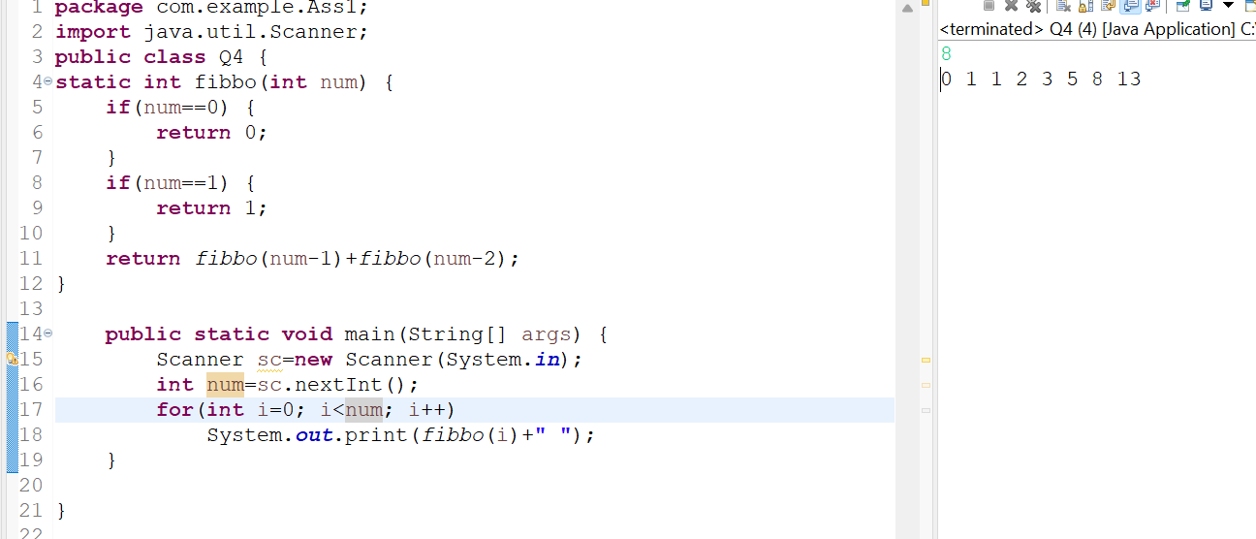

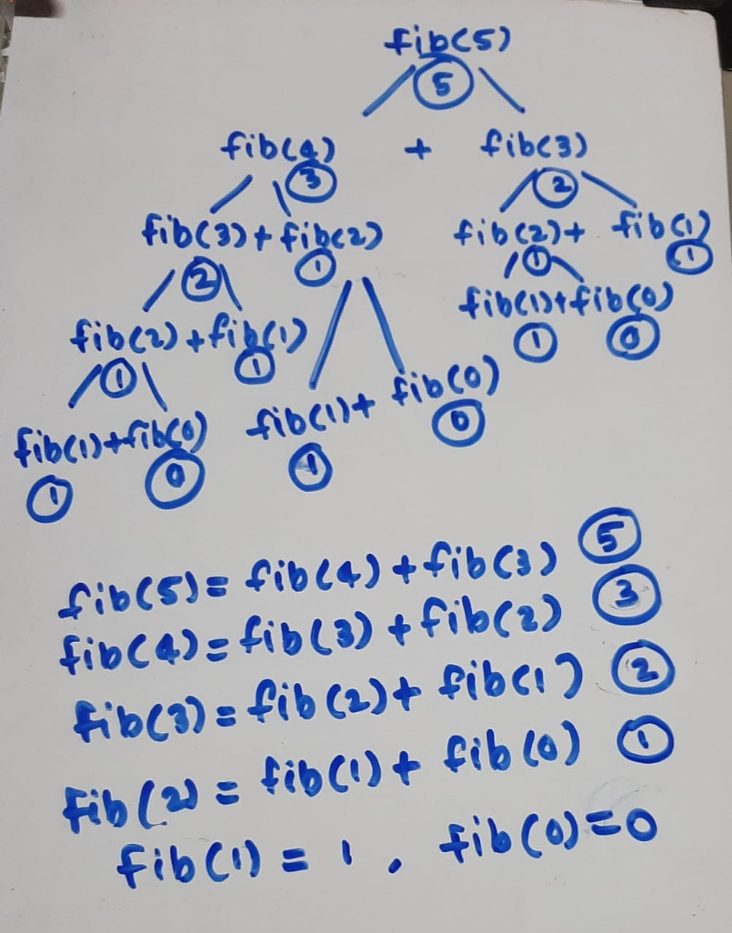

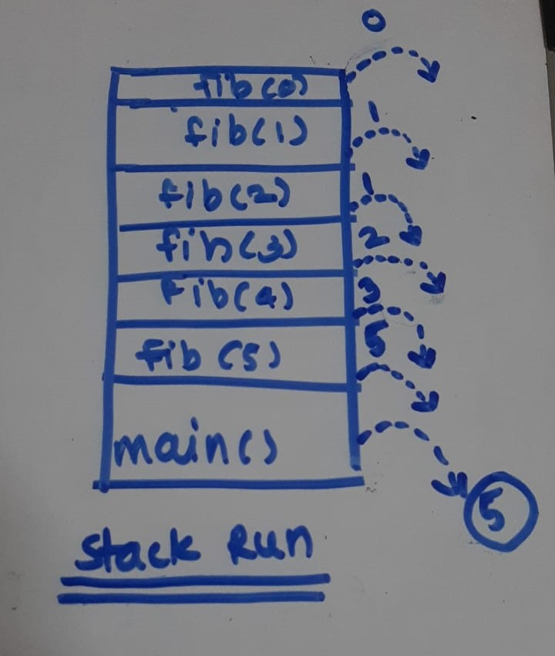

5. Find GCD

Problem: Write a Java program to find the Greatest Common Divisor (GCD) of two numbers.

Test Cases:

Input: a = 54, b = 24

Output: 6

Input: a = 17, b = 13

Output: 1

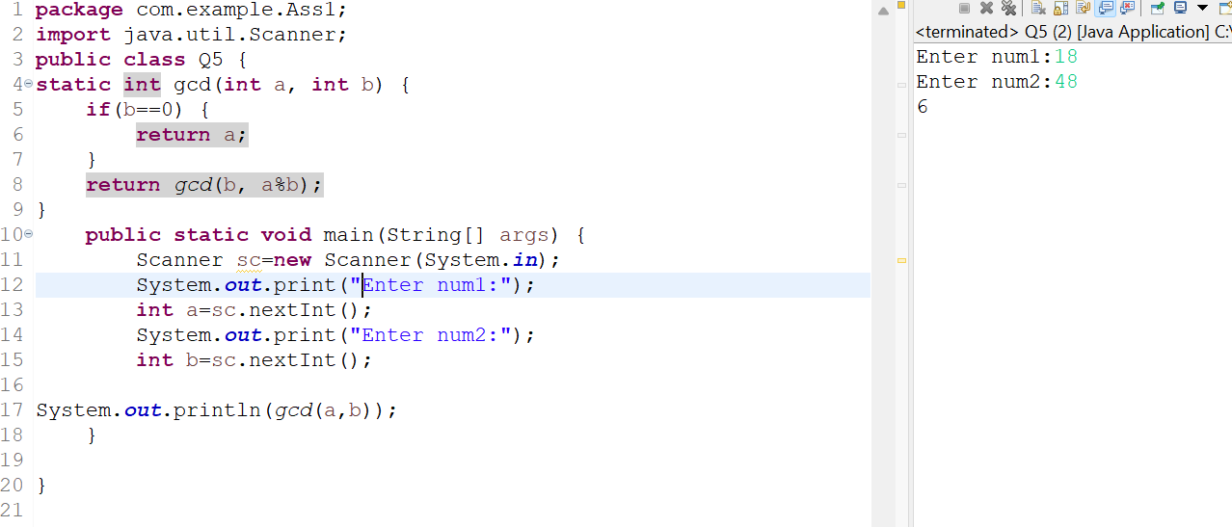

6. Find Square Root

Problem: Write a Java program to find the square root of a given number (using integer approximation).

Test Cases:

Input: x = 16

Output: 4

Input: x = 25

Output: 5

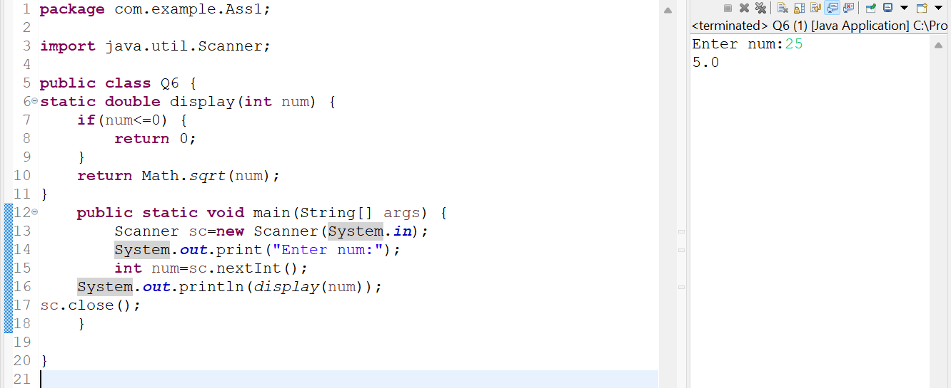

7. Find Repeated Characters in a String

Problem: Write a Java program to find all repeated characters in a string.

Test Cases:

Input: "programming"

Output: ['r', 'g', 'm']

Input: "hello"

Output: ['l']

8. First Non-Repeated Character

Problem: Write a Java program to find the first non-repeated character in a string.

Test Cases:

Input: "stress"

Output: 't'

Input: "aabbcc"

Output: null

9. Integer Palindrome

Problem: Write a Java program to check if a given integer is a palindrome.

Test Cases:

Input: 121

Output: true

Input: -121

Output: false

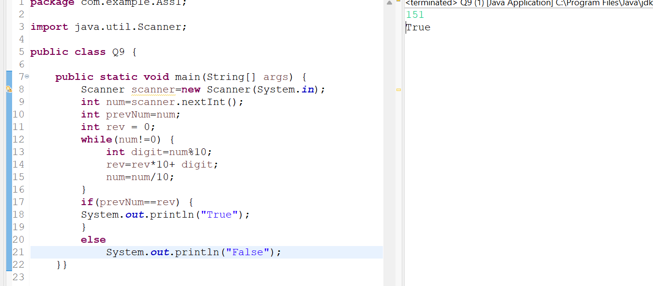

10. Leap Year

Problem: Write a Java program to check if a given year is a leap year.

Test Cases:

Input: 2020

Output: true

Input: 1900

Output: false

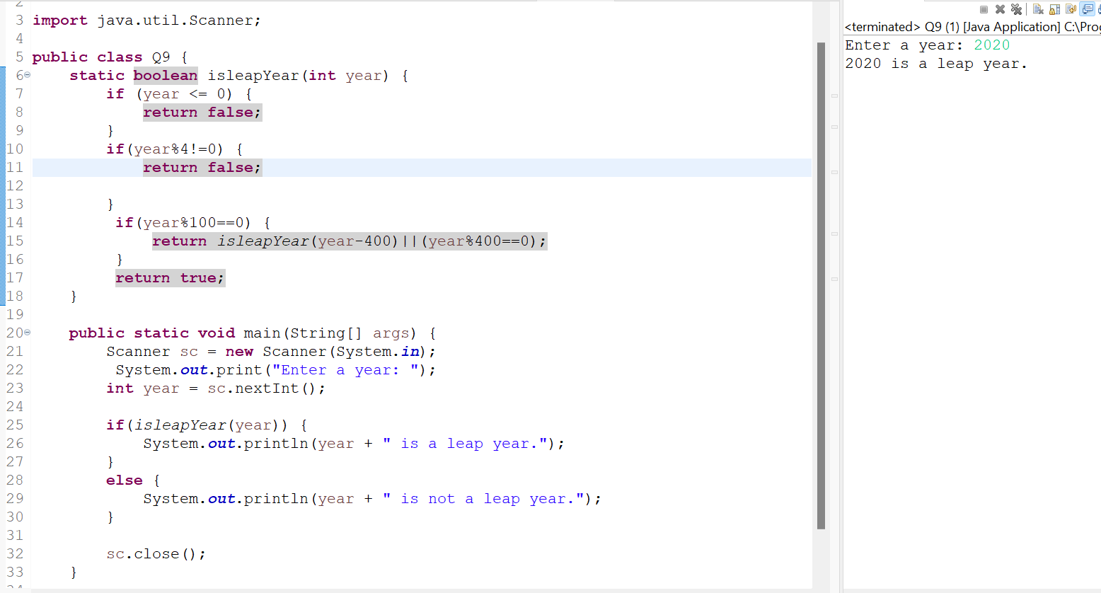

T.C.= O(1)